# 

*Team ID-PNT2022TMID14654*

*Project-Hazardous Area Monitoring For Industrial Plant Powered By IOT*

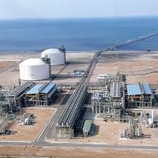

i am very much into experiments

"I'm proud of my own project

people's Great reaction

But they are very complex and and not feasible due to regulation

# 

# 

information from monitoring experts

people need to have a growth mindset to be creative

business needs cramps space for creativity and innovation

i feel very vulnerable when i call the help center

A bit of a free spirit

solution to that problem are not easy

Time consuming

Frustrations unstill finish our task's

New learning experiment

More connection due to the community